**New Lab 2**

Brian Webb – ID: 34775506

Student

CSC120-10187: Digital Design Fundamentals

Dinesh Sthapit / Carlos Rodriguez

May 8, 2022

User Flow Diagram

This application will be a basic todo list app using Spring and Vaadin. Below is the flow of how the user will interact with the application.

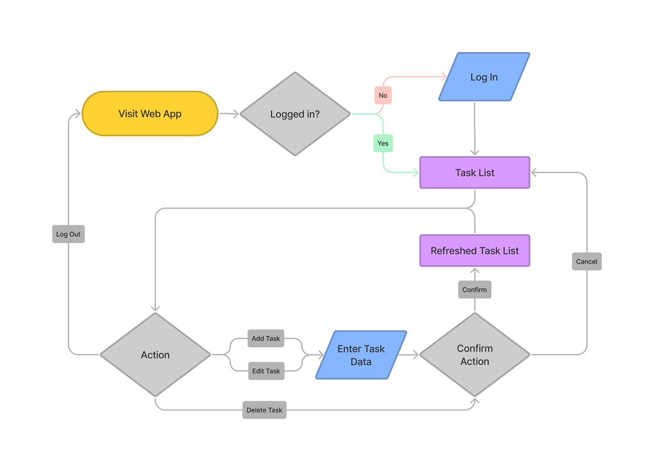

UML Diagram (database)

This is a simple application that will only require one main entity: Task.

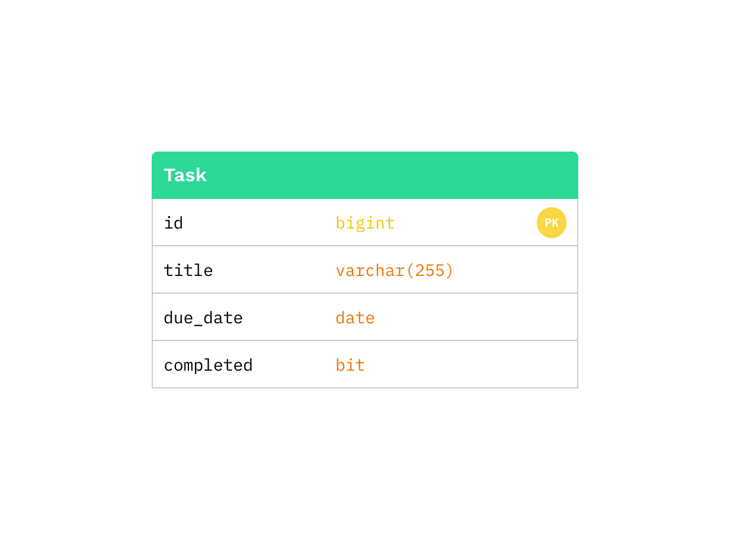

Github Repository

All code for this project will live here:

https://github.com/Brian-Webb/CSC120-2022/tree/main/CSC120-Final